Here are the instructions to connecting to the conference line by the mobile application with screen shots from our iPhone:

- Launch the app store and search: FreeConferenceCall.com

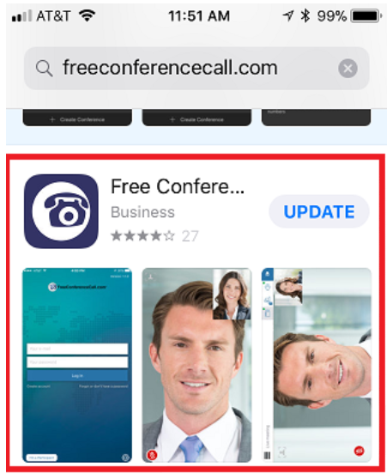

- Install, then launch FreeConferenceCall from your home page:
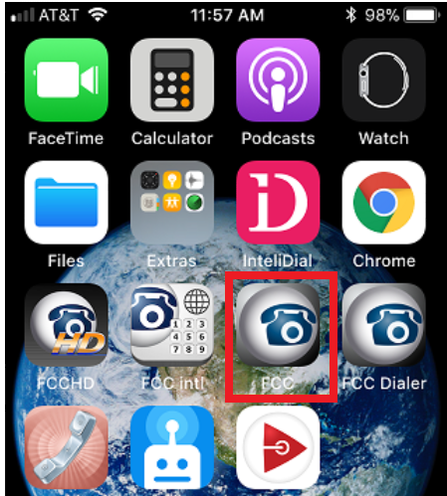

- If you see this, to the bottom left, click “I’m a participant”

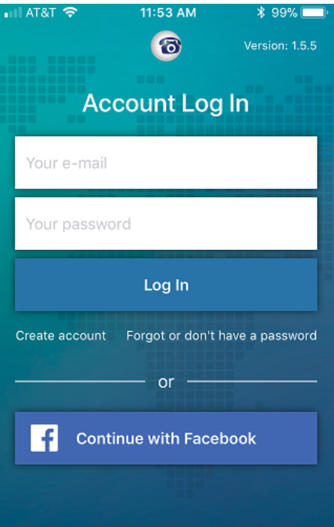

- Enter the online meeting ID: hdnewton55
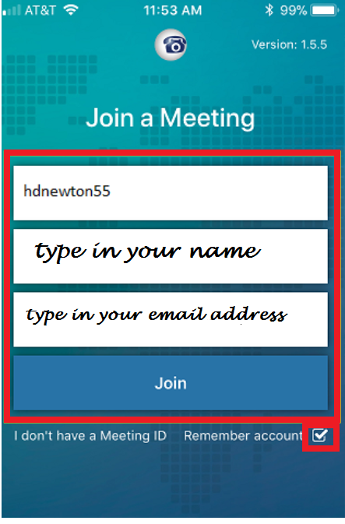
- Then enter your name and email address

- Once you click join click Internet to join over wi-fi, then you’re all set.

